 | NILE JOURNAL OF COMPUTING  Volume 1, Issue 1, 2026  https://doi.org/10.5281/zenodo.njc.2026.0101
――――――――――――――――――――――――――――――――――――――――――――――――――――――――――――――
Nigeria Road Management System: A Citizen-Centric Platform for Road Monitoring, Reporting, and Progress Tracking
Chibuzor Clinton Agada¹*, Ephraim Ayokunle Tackie Ofoli¹, Isaac Akorede-Abayomi Odujoko¹,
Aisha Mohammed Rasheed¹, Prince Arinze Wenceslaus Obinabo¹, Mubarak Ibrahim Audu¹, and Johnwendy C.N.¹
¹Department of Computer Science, Faculty of Natural and Applied Sciences, Nile University of Nigeria, Abuja, Nigeria
*Corresponding Author: Chibuzor Clinton Agada (e-mail: clinton.agada@nileuniversity.edu.ng)
ABSTRACT:
KEYWORDS: citizen reporting, construction progress tracking, crowdsourcing, inspection alerts, multi-tier architecture, Nigeria roads, spatial dashboard, transparency.
I. INTRODUCTION
Road transport is the main mode of transport for both passengers and goods in Nigeria. The national road network that covers an estimated 193,200 kilometres is the largest in West Africa (Farouq et al., 2017). This network is the main roadway of the cities, peri-urban areas and rural regions and accounts for more than 90% of passenger and goods travel. Despite its strategic significance, a significant part of the network is still in disrepair. The common sightings by motorists and pedestrians are deep potholes, structurally unsafe bridges, eroded shoulders and flooded carriageways (Adepoju, 2021). This chronic degradation causes a progressive deterioration of the vehicle, long delays and higher frequencies of accidents, which puts a significant socio-economic burden on society and the economy (Jaiye & Elisha, 2020).
Institutional fragmentation is a feature of the governance of road infrastructure in Nigeria. Federal roads are managed by the Federal Ministry of Works in consultation with the Federal Road Safety Corps (FERMA), State roads are managed by State Ministries of Works and Local roads are managed by Local Government Councils (Ogbu & Ezeh, 2019; Olojede et al., 2019). The Traffic law enforcement is delegated to different State traffic agencies (STAs) and the Federal Road Safety Corps (FRSC) (Ajiboye et al., 2020). In practice, such institutions are highly reliant on manual inspection, telephonic complaints, and paper documentation (Odinfono & Olawole, 2024). Unfortunately, in many cases of degraded roads, the road does not get logged for a long time before it's considered for a remedy. As such, common traffic violations (such as ignoring one-way signs, speeding, parking on private property, and littering in drains) are often unenforceable because of the lack of a citizen-friendly evidence reporting system (Umar et al., 2021).
Another important challenge is the lack of transparency in the construction and rehabilitation of the roads. Inadequate materials have been used by contractors and some contractors have been seen either leaving project sites after mobilisation funds have been released or leaving them before any subsequent stages of the project have been completed (Adepoju, 2021; Ugochi, 2020). Since there is no clear digital record of progress using photographs, it's very hard for supervisory personnel to see if contractual requirements have been met. Some of these can be directly addressed through a computerised system that allows citizens to report road defects and traffic violations, requires the contractors to submit progress photos and automatically alerts when the deadlines for inspections have passed.

The current road management practices in Nigeria are mostly manual, inefficient and uncoordinated. This prevailing system has four major drawbacks. First, citizens have no efficient digital system to submit their complaints about potholes or structural damage to roads with a geotagged photo, and complaints can only be made at the end of a physical visit or informally, which means that the repair process takes too long (Farouq et al., 2017). Secondly, construction activities are not recorded digitally, using an open format with photographic evidence, which allows for inferior construction methods and missed deadlines to remain unchecked (Adepoju, 2021). Third, traffic violations like one-way contraventions, illegal parking and dropping of waste on roads occurs without any form of regulation in place, without citizens having any way to submit supporting photos with evidence (Umar et al., 2018). Fourth, maintenance agencies do not have an automated notification system that can alert when a road or project inspection is due, resulting in poorly maintained infrastructure and maintenance schedules (Odinfono & Olawole, 2024).
To meet the needs of these exigencies, this study addresses three main research questions. Are there any existing systems for the management of road construction, maintenance, monitoring and enforcement of road traffic laws in Nigeria? What are the main drawbacks of current methods of road management, in terms of transparency, coordination between agencies, material quality, and public reporting? What do you think the functional attributes of a computerised Nigeria Road Management System should include to enable citizen reporting, track the progress of road construction, monitor the state of the roads and improve their decision-making by officials?
This study intends to develop, deploy and test a web-based Nigeria Road Management System (NRMS) that facilitates citizens to report defects and violations, monitor the construction progress and notify officials of outstanding inspections.
The study addresses the aim through three specific objectives: The first goal is to design the multi-level architecture of the system, the database schema, and the UML design for contractors, road officials and users. The second goal is to implement the core software modules, including citizen reporting of defects and violations with photographic upload, contractor progress monitoring, automated alerts for inspections and an administrative monitoring dashboard. The third goal is to test the final system to ensure a successful functioning, reporting and notification in representative scenarios.

II. RELATED WORKS
Research on road management and transport technology in Nigeria has produced a body of work that can be grouped into three broad categories: (i) administrative and institutional record-management systems, (ii) geospatial and emergency-response systems, and (iii) automated sensing and computer-vision systems. Although these studies demonstrate the potential of digital tools, they remain fragmented, institution-centred, and largely disconnected from public participation. This section synthesises the audited literature across five variables: system architecture, core features, technology stack, problem solved, and unaddressed gaps and concludes by identifying the gap that the proposed Nigeria Road Management System (NRMS) addresses.

2.1 Administrative and Institutional Record-Management Systems
A first cluster of studies focuses on digitising internal government records. Sese (2020) designed a client–server distributed database to centralise traffic offence records for the Federal Road Safety Corps (FRSC) across states and local government areas. The system solved a genuine problem of record fragmentation, but it was restricted to internal officers and offered no citizen-facing reporting, photo uploads, or road-condition tracking. Similarly, Dabo and Yunus (2020) demonstrated that GIS tools could map road facilities in Katsina, yet the resulting system remained an internal database inaccessible to ordinary citizens. Akanbi and Abegunde (2020) extended this institutional logic to a mobile system for vehicle plate registration and accident logging for the FRSC, but their solution excluded road-surface defect reporting and construction-progress monitoring.
Taken together, these systems share a common architectural assumption: the citizen is a passive data subject, not an active participant. Data flows inward to the agency, and no feedback loop returns to the public. This limits both accountability and the volume of ground-level road-condition data that can be collected. Farouq et al. (2017) provide empirical support for the consequences of this limitation: their audit of road-defect logging in Kano State found serious weaknesses and citizen frustration with manual, paper-based reporting. Their study, however, remained a survey-based diagnosis and did not produce a functioning web or mobile platform.

2.2 Geospatial and Emergency-Response Systems
A second cluster applies spatial analysis to road safety. Audu et al. (2021) developed a spatial decision-support system using ArcGIS 10.3, Network Analyst, and GPS to map accident hotspots and calculate shortest ambulance routes in Ibadan. The system improved emergency response times and demonstrated the value of geospatial intelligence in road management. Its scope, however, was entirely post-crash: it addressed emergency medical response and excluded defect reporting, preventive maintenance, and contractor tracking. The system therefore solves a downstream symptom rather than the upstream problem of deteriorating road conditions.

2.3 Automated Sensing and Computer-Vision Systems
A third cluster explores automated enforcement and monitoring. Umar et al. (2021) built an image-processing client–server system using a k-NN algorithm, MATLAB, and roadside cameras to detect vehicles running red lights through licence-plate detection and optical character recognition (OCR). The system achieved automated violation detection, but it required specialised fixed infrastructure and did not handle citizen reporting or road-condition monitoring. Its architecture is capital-intensive and location-bound, making it difficult to scale to the distributed, low-cost monitoring needs of Nigerian road networks.

2.4 Cross-Cutting Limitations and Data-Quality Concerns
Across all three clusters, several cross-cutting limitations emerge. First, public involvement is systematically absent. Toriola-Coker et al. (2020) identified the lack of public participation as a key reason public road projects fail, yet none of the audited systems provides a citizen-facing channel for reporting defects or verifying contractor progress. Second, data collection remains inconsistent. Odinfono and Olawole (2024) found that 55% of traffic crash data collection in southwestern Nigeria still relies on non-standard paper forms, producing inconsistencies between police and road-safety records. Third, existing systems are functionally isolated: each addresses a narrow slice of the road-management problem offence records, hotspot mapping, or violation detection — without integrating citizen crowdsourcing, contractor milestone tracking, and inspection alerts into a single platform.

2.5 Summary of Audited Systems
TABLE I: Summary of Related Systems Audited Across the Five Project Variables
Study & Year | Architecture | Core Features | Tech Stack | Problem Solved | Unaddressed Gap
Afieroho et al. (2023) | Web E-Government Framework | Public project tracking, citizen adoption survey | SPSS, PLS-SEM, Web Portal | High public willingness to adopt digital tracking tools | Theoretical survey model only; no functioning tool with photo reporting
Farouq et al. (2017) | Relational Database Audit | Road defect logging, user dissatisfaction survey (Kano) | SPSS, Average Index Analysis | Exposed weaknesses and frustration with manual defect logging | Fully manual and paper-based; no web or mobile platform
Sese (2020) | Client–Server Distributed DB | Centralised traffic offence database for FRSC | Client–Server, Distributed SQL | Centralised offence records across states and LGAs | Internal officers only; no citizen reporting, photo uploads, or road tracking
Audu et al. (2021) | Spatial Decision Support (GIS) | Accident hotspot mapping, ambulance routing (Ibadan) | ArcGIS 10.3, Network Analyst, GPS | Improved emergency response times | Post-crash only; excludes defect reporting and contractor tracking
Umar et al. (2021) | Image Processing Client–Server | Licence plate detection and OCR | k-NN, MATLAB, Camera | Automatic detection of red-light violations | Requires fixed roadside cameras; no citizen reporting or condition monitoring
Dabo and Yunus (2020) | GIS Internal Database | Mapping of road facilities (Katsina) | GIS | Effective mapping of road assets | Internal database; inaccessible to ordinary citizens
Akanbi and Abegunde (2020) | Mobile System | Vehicle plate registration, accident logging (FRSC) | Mobile Platform | Digitised plate registration and accident logs | No road-surface defect reporting or construction-progress monitoring
Odinfono and Olawole (2024) | Survey / Data Audit | Analysis of crash data collection practices | Survey Analysis | Revealed 55% reliance on non-standard paper forms | No system proposed; diagnostic only
Toriola-Coker et al. (2020) | Conceptual / Empirical Study | Public participation in road projects | — | Identified lack of public involvement as failure factor | No digital platform proposed

2.6 Proposed Improvement and Value-Add Delta
The reviewed literature reveals a consistent pattern: existing systems are institution-centred, functionally isolated, and closed to public participation. To address these gaps, the proposed Nigeria Road Management System (NRMS) integrates citizen crowdsourcing, contractor milestone tracking, and automated inspection alerts into a single platform. Table II compares standard existing practice with the proposed NRMS contribution.
TABLE II: Value-Add Comparison (Standard Practice vs. Proposed NRMS)
Functional Area | Standard / Existing Practice | Proposed NRMS Contribution (Value-Add Delta)
Citizen Defect Reporting | Slow verbal complaints, physical office visits, or unverified social media posts without precise location data | Web and mobile interface for reporting potholes and violations with attached photos and automatic GPS coordinates
Contractor Progress Tracking | Contractor-submitted paperwork with little or no public photo verification before payment | Dedicated contractor portal requiring timestamped progress photos for each construction milestone before inspection clearance
Inspection Alerts | Irregular manual visits with no automated reminder when inspections are overdue | Automated background engine that checks the database daily and sends email/SMS alerts when a road inspection is overdue (> 30 days)
Official Dashboard & Analytics | Disorganised paper files and separate spreadsheets with no interactive map or condition status | Central dashboard showing monitored roads, critical road counts, ongoing construction projects, and overdue inspections on an interactive map
The value-add delta is therefore not merely additive but architectural: NRMS shifts the citizen from passive subject to active data contributor, converts isolated institutional records into an integrated public-accountability platform, and replaces sporadic manual inspection with automated, rule-based monitoring.
III. METHODOLOGY

3.1 Research Design
This study adopts a Design Science Research (DSR) methodology, which is appropriate for research whose primary contribution is an innovative software artefact. DSR is well-established in information systems and software engineering as the paradigm concerned with extending organizational capabilities through the design and evaluation of artefacts intended to solve practical problems (Hevner et al., 2004). Unlike behavioral science, which seeks to explain or predict phenomena, design science generates knowledge through the design and evaluation of artefacts (Hevner et al., 2004).
The DSR process follows Wieringa’s (2014) design cycle, which iterates over two activities: designing an artefact that improves something for stakeholders and subsequently empirically investigating the performance of that artefact in its context. This “validation in context” principle is central to the methodology: the artefact is not merely built but must be shown to address the identified problem within its operational environment (Wieringa, 2014).
Consistent with departmental guidelines, the system architecture is fully specified before implementation begins, ensuring traceability between design decisions and identified requirements.
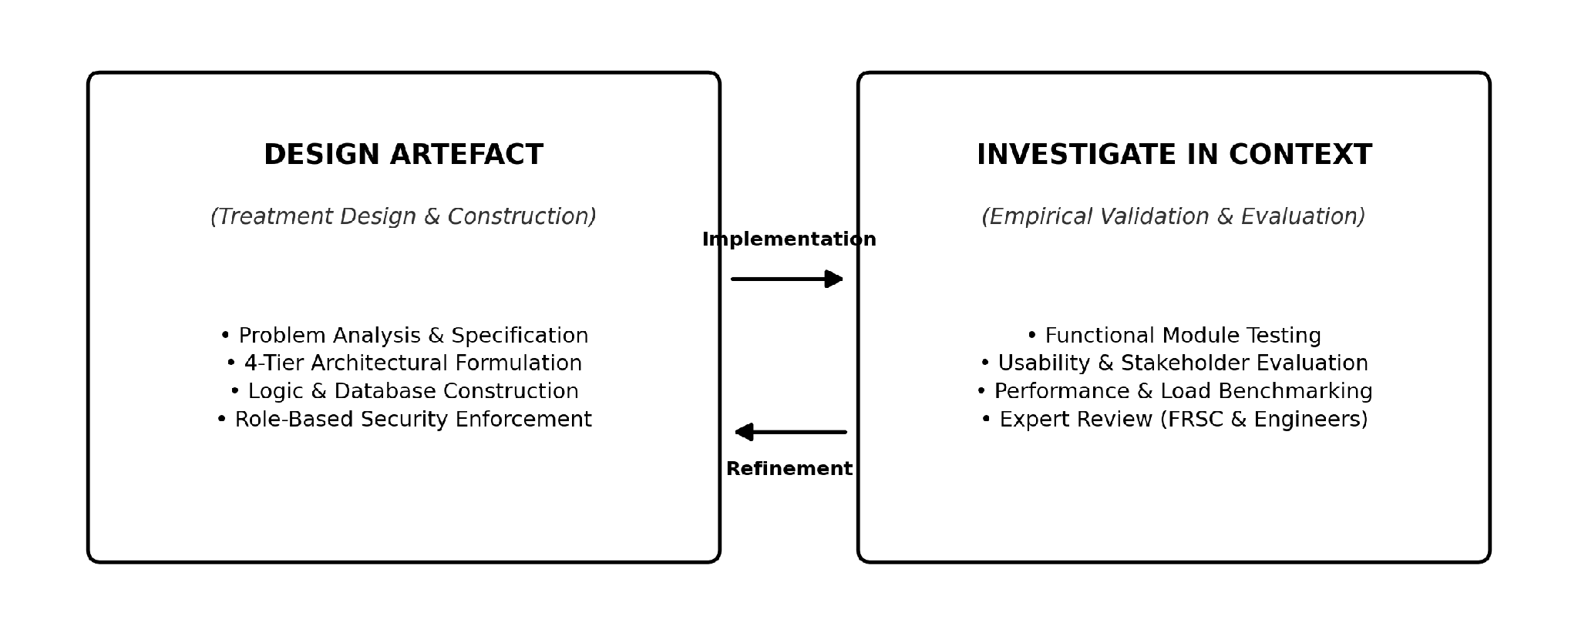
Figure 3.1: Wieringa's (2014) Design Science Research Cycle Applied to NRMS.

3.2 System Architecture
The Nigeria Road Management System (NRMS) employs a four-tier architecture that separates concerns across presentation, business logic, data persistence, and notification services.
TABLE III: Architectural Tiers and Component Allocations

Tier | Responsibility | Components
Client Tier | User interaction | Citizen Portal, Contractor Portal, Officials Dashboard
Logic Tier | Business rules and workflow | User Management, Report Management, Contractor Progress, Inspection Alert Engine, Map Analytics
Data Tier | Persistence and caching | PostgreSQL + PostGIS, Cloudinary/S3, Redis
Output Tier | Notifications and reporting | SMS/Email Services, Map Rendering (Leaflet/OpenStreetMap), PDF/CSV Export
This separation yields three design properties: security (role-based access enforced server-side), maintainability (independent tier modification), and scalability (horizontal scaling without client redesign).
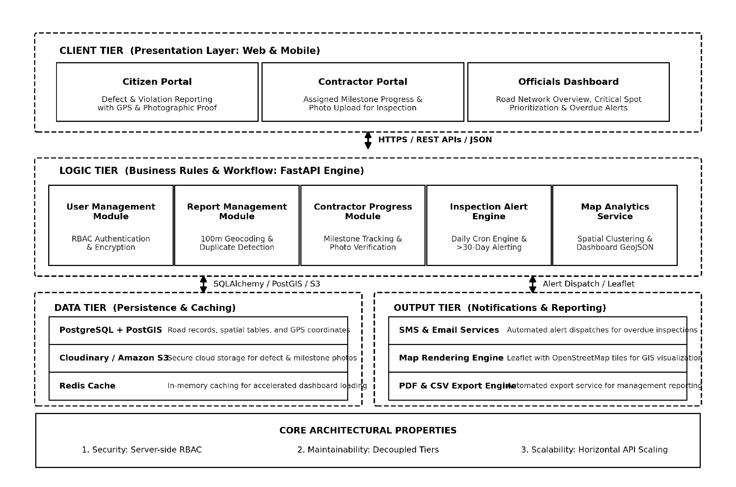
Figure 3.2: Detailed NRMS Four-Tier System Architecture.

3.3 Functional Modules
Client Tier. The Citizen Portal provides a responsive web and mobile interface for reporting road defects (potholes, erosion) and traffic violations (one-way driving, illegal parking) with photographic evidence and GPS coordinates. The Contractor Portal enables registered contractors to view assigned projects, upload timestamped progress photographs for completed milestones, and request inspection. The Officials Dashboard displays monitored road counts, critical road spots, active projects, and overdue inspection counts.
Logic Tier. The User Management Module implements registration, secure authentication, password encryption, and role-based access control across four roles: citizen, contractor, inspector, and administrator. The Report Management Module receives citizen submissions, performs geospatial duplicate detection using a 100-metre radius threshold, and assigns urgency priority. The Contractor Progress Module tracks project stages, computes percentage completion, and stores progress photographs for verification. The Inspection Alert Engine executes daily database queries to flag road sections or projects whose last inspection exceeds 30 days. The Map Analytics Service processes GPS data to spatially cluster reported defects and formats data for dashboard rendering.
Data Tier. PostgreSQL with PostGIS provides spatial data storage for road records and GPS coordinates. Cloudinary/S3 handles photograph storage. Redis provides caching for dashboard performance.
Output Tier. Notification Services dispatch SMS and email alerts for overdue inspections. Map Rendering uses Leaflet with OpenStreetMap tiles. Report Generation produces PDF/CSV exports for management.

3.4 Data Flows
The operational interactions across actors, application logic, and persistence layers are defined by four standardized data flows (F1 through F4).
TABLE IV: System Operational Data Flows (F1 to F4)

Flow | Actor | Process | System Response
F1: Report Submission | Citizen | Selects defect type, attaches photo, submits GPS coordinates | Stores photo in cloud, persists report in database, returns tracking number
F2: Progress Upload | Contractor | Selects milestone, uploads progress photos | Records update as “Pending Inspection,” notifies supervising officer
F3: Inspection Alert | System | Daily scan for inspections >30 days overdue | Generates alert, dispatches SMS/email to maintenance engineer
F4: Administrative Triage | Official | Reviews defects on map, assigns maintenance team | Status transitions from “Under Review” to “Assigned”
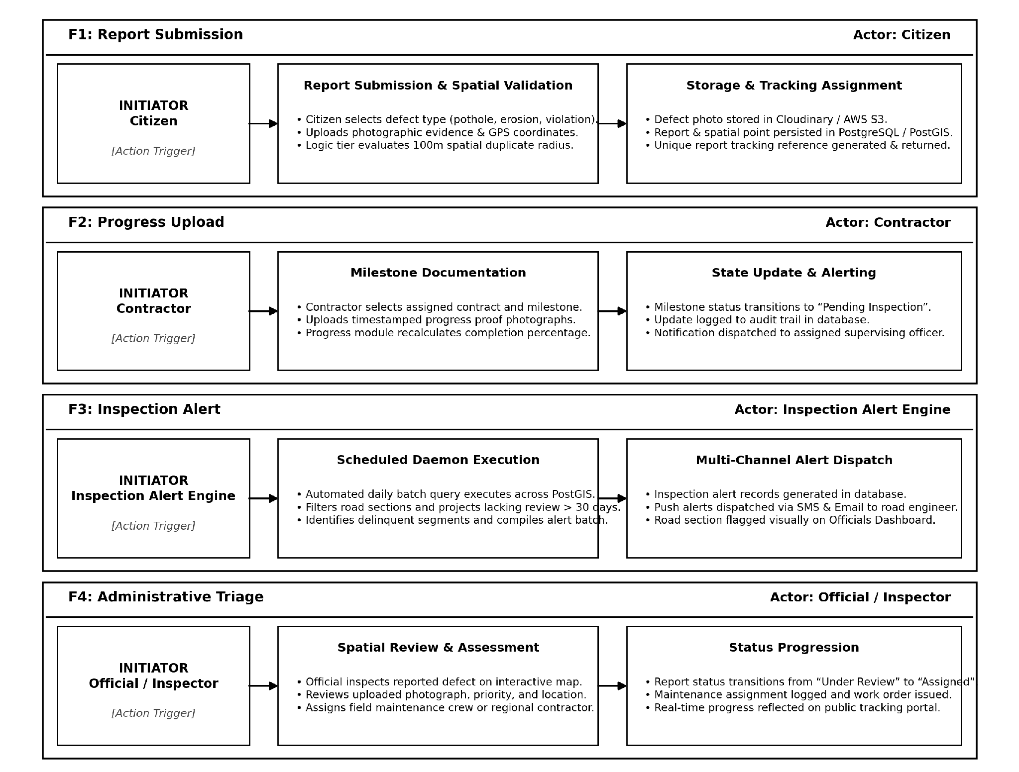
Figure 3.3: End-to-End System Operational Data Flows.

3.5 Technology Stack
Technology selection was guided by three criteria: reliability, open-source availability, and deployment simplicity.
TABLE V: Technology Selection and Rationale

Layer | Technology | Rationale
Frontend | HTML, CSS, JavaScript | Responsive mobile performance; dashboard and form support
Backend | FastAPI | High-throughput concurrent photo upload and API request handling
Database | PostgreSQL + PostGIS | Native spatial queries for GPS coordinates and geographic clustering
Storage/Cache | Cloudinary + Redis | Secure off-database media storage; accelerated dashboard loading
Mapping/Notification | OpenStreetMap + Leaflet; SMS/Email | Open-source interactive mapping; reliable alert delivery

3.6 Design Traceability
Each architectural decision traces to a documented gap in the literature. The 100-metre duplicate detection rule addresses the data-quality inconsistency identified by Odinfono and Olawole (2024). The automated 30-day inspection alert addresses irregular manual inspection practices. The contractor photo-verification workflow addresses the absence of public accountability in payment processes. This traceability ensures the artefact responds directly to documented deficiencies rather than representing a purely technical exercise.

3.7 Evaluation Plan
Following DSR principles (Hevner et al., 2004; Wieringa, 2014), the artefact will be evaluated through four complementary methods:
- Functional validation: Testing each module against specified requirements (duplicate detection accuracy, alert trigger reliability).
- Usability evaluation: Task-based testing with representative citizens, contractors, and officials.
- Performance benchmarking: API response times, photo upload throughput, and map rendering latency under concurrent load.
- Expert review: Structured walkthroughs with road engineers and FRSC officials to assess operational fit.
REFERENCES
Adepoju, O. O. (2021). Analysis of road transportation infrastructure construction and maintenance for sustainable development in South-Western Nigeria. Journal of Sustainable Development of Transport and Logistics, 6(1), 4–15. https://doi.org/10.14254/jsdtl.2021.6-1.4
Afieroho, P., Perkins, R., Zhou, X., Hoanca, B., & Protasel, G. J. (2023). Adopting e-government to monitor public infrastructure projects execution in Nigeria: The public perspective. Heliyon, 9(7), e18552. https://doi.org/10.1016/j.heliyon.2023.e18552
Ajiboye, A. O., Kolawole, O., & Adebanjo, A. A. (2020). Assessment of the statutory duties of Federal Road Safety Corps aimed at reducing crashes and carnages in Ibadan, Southwest Nigeria. Journal of Art, Architecture and Built Environment, 3(2), 968. https://doi.org/10.32350/jaabe/2020/32/968
Akanbi, O. D., & Abegunde, O. (2020). Design and implementation of mobile information system for Federal Road Safety Corps (FRSC) of Nigeria. International Journal of Sensor Networks and Data Communications, 9(2), 1–6.
Audu, A. A., Iyiola, O., Popoola, A., Adeleye, B., Medayese, S., Mosima, C., & Blamah, N. (2021). The application of geographic information system as an intelligent system towards emergency responses in road traffic accident in Ibadan. Journal of Transport and Supply Chain Management, 15, a546. https://doi.org/10.4102/jtscm.v15i0.546
Babatunde, A. A., Adewuyi, G. K., & Oyekola, M. A. (2019). Road condition monitoring of major and minor route in part of Ibadan metropolis using geo-spatial approach. Journal of Geography, Environment and Earth Science International, 22(4), 1–12. https://doi.org/10.9734/jgeesi/2019/v22i430156
Dabo, M. Z., & Yunus, S. (2020). Road transport information system: A panacea for road transport facility management in Katsina Local Government, Katsina State, Nigeria. FUDMA Journal of Sciences, 4(2), 230–238. https://doi.org/10.33003/fjs-2020-0402-230
Farouq, M. M., Anwar, F., Baba, Z., Labbo, M. S., & Aliyu, D. (2017). Road maintenance management in Kano State, Nigeria: Case study of Kano metropolitan. IOSR Journal of Mechanical and Civil Engineering, 14(3), 50–62. https://doi.org/10.9790/1684-1403035062
Gambo, N., & Musonda, I. (2021). Effect of the Fourth Industrial Revolution on road transport asset management practice in Nigeria. Journal of Construction in Developing Countries, 26(1), 21–42. https://doi.org/10.21315/jcdc2021.26.1.2
Hevner, A. R., March, S. T., Park, J., & Ram, S. (2004). Design science in information systems research. MIS Quarterly, 28(1), 75–105. https://doi.org/10.2307/25148625
Jaiye, D., & Elisha, A. (2020). The menace of uncontrolled trailer/truck loads and the use of weigh-in-motion device on carriageways in Nigeria. International Journal of Transport Development and Integration, 4(1), 1–13. https://doi.org/10.2495/tdi-v4-n1-1-13
Medayese, S., Alfa, M. T., Abd’Razack, N. T., & Agbawn, F. O. (2019). Analysis of the extent of red light running in Minna, North-Central Nigeria. Journal of Contemporary Urban Affairs, 3(2), 124–136. https://doi.org/10.25034/ijcua.2018.470zd9
Ndugbu, L. N., & Ndugbu, U. K. (2021). Road offence information management system in Nigeria: A most needed technology intervention. Journal of Computer Science and Engineering, 2(1), 164–172. https://doi.org/10.36596/jcse.v2i1.164
Odinfono, J., & Olawole, M. (2024). Road traffic crash data in Southwestern Nigeria: A qualitative analysis of sources, contents and management methods. Traffic Injury Prevention, 25(8), 1–9. https://doi.org/10.1088/15389588.2024.2398670
Ogbu, S., & Ezeh, F. (2019). Federal vs. state roads: Assessing the influence of intergovernmental relations models on road maintenance in Nigeria. European Journal of Business and Management Research, 4(5), 94–102. https://doi.org/10.24018/ejbmr.2019.4.5.94
Olojede, O., Agbola, S., & Samuel, K. (2019). Residents’ assessment of local government road infrastructure delivery in Ile-Ife, Nigeria. Local Economy: The Journal of the Local Economy Policy Unit, 34(6), 570–588. https://doi.org/10.1177/0269094219857044
Sese, T. E. (2020). Framework for client-server distributed database system for Federal Road Safety Commission Nigeria. Advances in Social Sciences Research Journal, 7(5), 183–195. https://doi.org/10.14738/assrj.75.8237
Toriola-Coker, L., Alaka, H., Agbali, M., Bello, W., Pathirage, C., & Oyedele, L. (2020). Marginalization of end-user stakeholders in public private partnership road projects in Nigeria. International Journal of Construction Management, 22(14), 2736–2748. https://doi.org/10.1080/15623599.2020.1766189
Ugochi, M. U. (2020). Road pavement failure and exploratory analysis of requirements for effective management of highway maintenance projects. International Journal of Innovative Research and Development, 9(8), 57–67. https://doi.org/10.24940/ijird/2020/v9/i8/aug20057
Umar, B., Olaniyi, O., Agajo, J., & Isah, O. R. (2021). Traffic violation detection system using image processing. Computer Engineering and Applications Journal, 10(2), 371–382. https://doi.org/10.18495/comengapp.v10i2.371
Wieringa, R. J. (2014). Design science methodology for information systems and software engineering. Springer. https://doi.org/10.1007/978-3-662-43839-8

